ASSIGNMENT 8.1

1. When to use (Rapid Application Development) RAD model and When not to use (Rapid Application Development) RAD model?

Rapid Application Development(RAD) can be used:

- when the rapidity of the development is given more importance than the quality. In RAD, how rapidly we develop the software is very improtant.
- when the focus is mainly on Development rather than involving the customer too much. In RAD, compared to the traditional approach customer involvement is there but not as much as Ajile, but in RAD focus is on Development.
- When incremental is required, but the quality may be compromised.
- When change in requirements are there due to a dynamic environement.
- When changes are there or the customer is not having a better end vision.
- When changes are given importance than doccumention.
- To do small projects and when there are high time constraints.
- If the developers finds it difficult to write codes or take more time, where same codes can be used for different uses.
- If the system can be modularized. If its a long project with a single module, then it would be difficult to do with RAD.
- If the budget available is high for paying the experts, buying automated code generation tools,...
- If there is a high availability of expert designers are there for modelling
- if domain experts are available, because the change is rapid and hence there is a need to understand the Business. Trying to know the requirement itself should not take much time. Small and Fresh teams cannot be used
- if there is a scope to reuse the codes.

It is not recommended to use Rapid Application Development(RAD):

- if the team consists of freshers or people with less domain knowledge
- if the budget is limited and is not available to purchase automated code generation tools
- if the project cannot be modularized or if the only one long module is there
- if more detailed doccumentation is required
- if the projects are of long duration.
- If more focus is given to quality than rapidity of development
- if there are no high end resources

if the customer is not ready to get involved much like in traditional approach

2. Define an ER diagram of a software Organization with all the relationship
model that was discussed in the classroom

Consider the example of Speridian Technologies.

SUPERVISION
EMPLOYEE
NAME
SEX
ADDRESS
SALARY
DOB
FNAME
LNAME
DEPARTMENT
PROJECT
CONTROLS
MANAGES
WORKS_IN
DEP-NAME
DEP-NUMBER
LOCATION
WORKS-ON
NAME
NUMBER
LOCATION
DEPENDENT
NAME
SEX
DOB
RELATION
DEPENDENTS_OF
EMPLOYEE-ID
CLIENT
ADDRESS
LOCATION
GIVES

NAME

The Entity Diagram represents the infromation system of an organization in a graphical way. Here the entities are EMPLOYEE, DEPARTMENT, PROJECT, CLIENT, and DEPENDENT. The attribute for the entity employee are address, salary, name, dob, employee id, sex. We can see that there is a relationship between the employee and the department. Multiple employees works in one department. One department manages multiple employees. Similarly one department controls multiple projects.

3. Describe the Entity Relationships for the following diagram

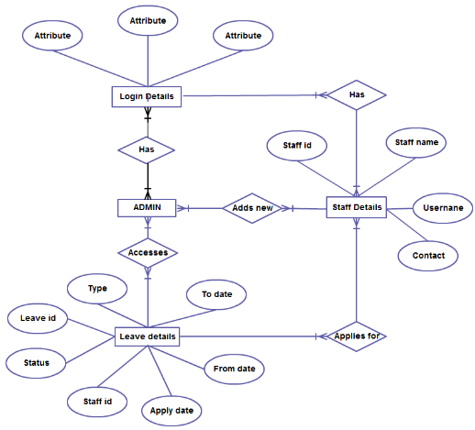

In the above ER Diagram, the entities are:
Login Details
Admin
Leave Details
Staff details

Login Details has the 3 attributes: attribute, attribute and attribute. The Login Details has a relation with the ADMIN. Multiple logins has multiple login details. The entity Login Details has different attributes like Staff id, type, leave id, status, apply date, from date, to date. Multiple Leave details can be accesses by multiple ADMIN. The entity Login Details also has a relationship with the staff details, which has attributes like staff id, staff name, username, contact. Multiple staff details applies for multiple Leave details. Even the staff details has relationship with Login details. Also the multiple ADMINS can add multiple Staff details.
Here the primary key Staff id is a foreign key for leave details

